目錄
1 T-Road 介接服務 2
▪ apiService呼叫服務 2
• 範例請求指令 2
• 傳入參數規格 3
• 回傳結果規格 3
2 T-Road 檔案傳輸服務 5
▪ createFileTransfer建立檔案傳輸交易 5
• 範例請求指令 5
• 傳入參數規格 6
• 回傳結果規格 7
▪ startFileTransfer開始檔案傳輸 8
• 範例請求指令 8
• 傳入參數規格 9
• 回傳結果規格 10
▪ fileTranferStatus檔案傳輸狀態 11
• 範例請求指令 11
• 傳入參數規格 11
• 回傳結果規格 12
3 更新非同步API傳輸狀態API 14
▪ asyncApiCallback更新傳輸狀態 14
• 範例請求指令 14
4 查詢傳輸紀錄API 15
▪ transactionApi查詢傳輸紀錄 15
• 範例請求指令 15
• 傳入參數規格 15
• 回傳結果規格 17

- T-Road 介接服務
- apiService呼叫服務
呼叫取得API(含非同步)及GSP既有系統資料。
若呼叫非同步API，提供端AP收到請求時，需將Header中的tr_callback內容儲存。當非同步資料準備完成後，需呼叫更新非同步API傳輸狀態API，並傳入tr_callback內容。
- 範例請求指令
curl -X POST "https://xxxxxx.troad.gov.tw:8446/client/apiService" -H "accept: */*" -H "client_api_key: xxx" -H "Content-Type: application/json" -d "{ \"agreementId\": \"xxx\", \"requestBody\": \"e30=\"}" -k
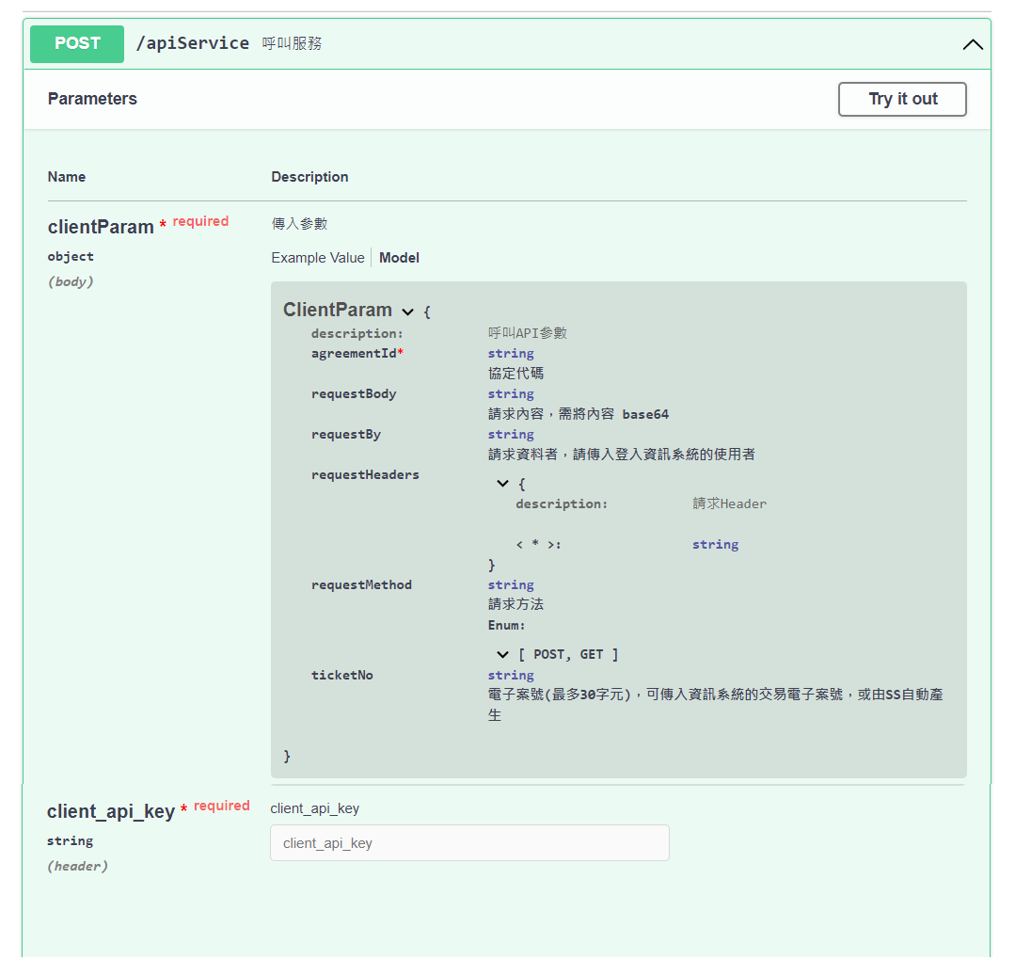
- 傳入參數規格
{
"agreementId": "string",
"requestBody": "string",
"requestBy": "string",
"requestHeaders": {
"additionalProp1": "string",
"additionalProp2": "string"
},
"requestMethod": "POST",
"ticketNo": "string"
}
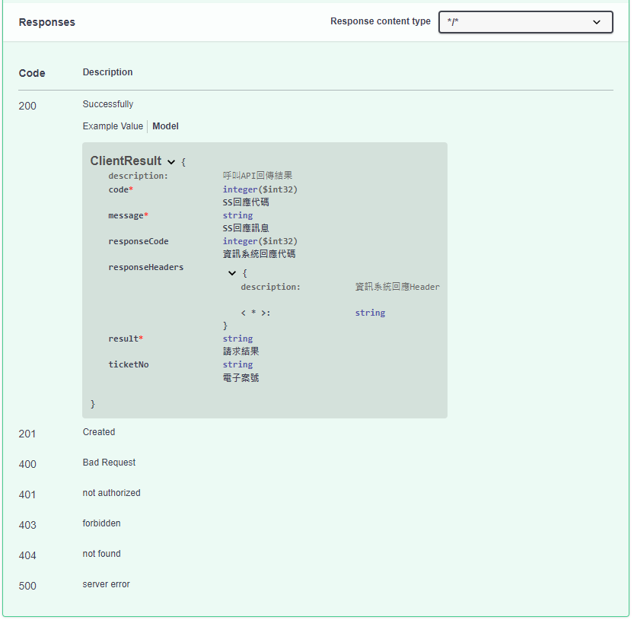
- 回傳結果規格
{
"code": 0,
"message": "string",
"responseCode": 0,
"responseHeaders": {
"additionalProp1": "string",
"additionalProp2": "string"
},
"result": "string",
"ticketNo": "string"
}

- T-Road 檔案傳輸服務
- 檔案傳輸流程
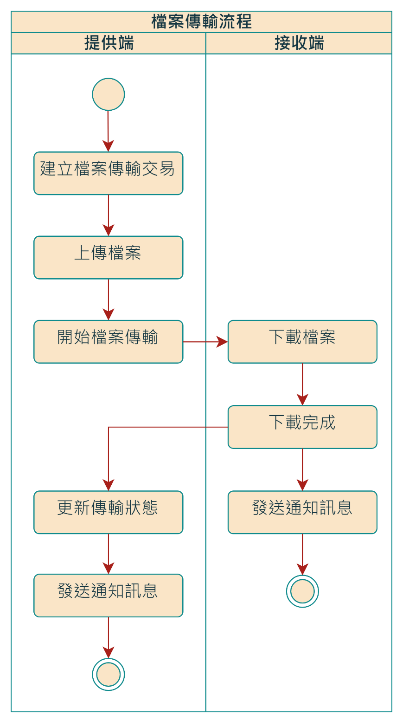
- createFileTransfer建立檔案傳輸交易
回傳一日有效之SFTP帳號密碼，供上傳欲傳輸的檔案。
- 範例請求指令
curl -X POST "https://xxxxx.troad.gov.tw:8446/client/createFileTransfer" -H "accept: */*" -H "client_api_key: xxx" -H "Content-Type: application/json" -d "{ \"agreementId\": \"0001\", \"ticketNo\": \"20221005-0000000005\"}" -k
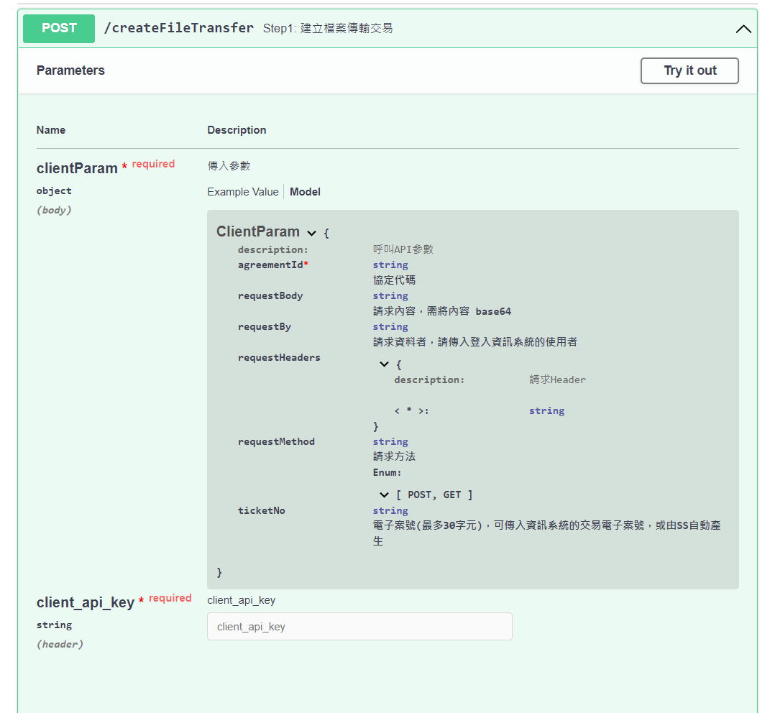
- 傳入參數規格
{
"agreementId": "string",
"requestBody": "string",
"requestBy": "string",
"requestHeaders": {
"additionalProp1": "string",
"additionalProp2": "string",
},
"requestMethod": "POST",
"ticketNo": "string"
}
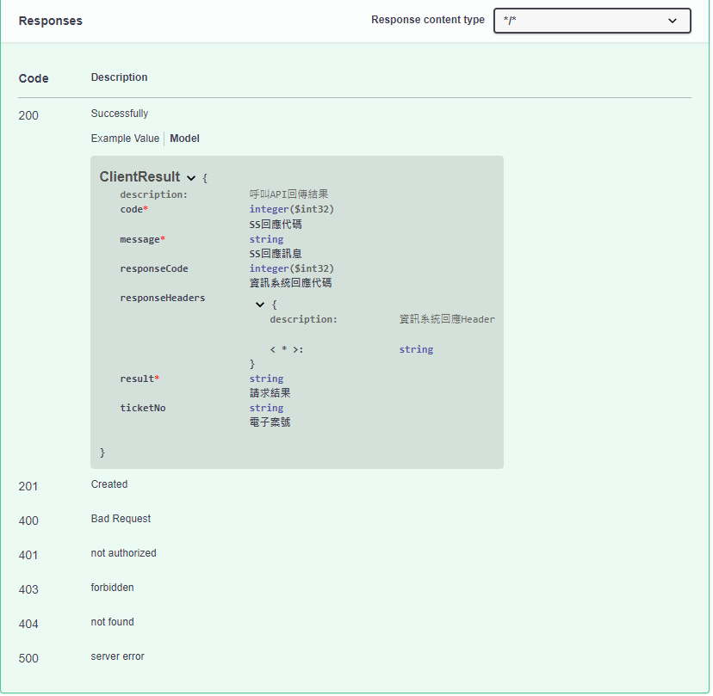
- 回傳結果規格
{
"code": 0,
"message": "string",
"responseCode": 0,
"responseHeaders": {
"additionalProp1": "string",
"additionalProp2": "string"
},
"result": "string",
"ticketNo": "string"
}

- startFileTransfer開始檔案傳輸
檔案上傳完成，呼叫此API將資料傳送至請求端SS。請求端業務承辦人員會收到MAIL此筆檔案傳輸結果。
若請求端於介接外部API管理設定通知發送位址，傳輸完成後會發送通知至通知發送位址，並於Header中帶入AgreementId(協定代碼)、TicketNo(電子案號)及ResponseStatus(傳輸結果)。呼叫startFileTransfer傳入的requestMethod參數可以控制發送通知用POST(預設)或GET，若用POST則會將傳入的requestBody base64 decode內容一併POST至通知發送位址。
若提供端於外部介接本伺服器API管理設定通知發送位址，傳輸完成後會發送通知至通知發送位址，並於Header中帶入AgreementId(協定代碼)、TicketNo(電子案號)及ResponseStatus(傳輸結果)。呼叫startFileTransfer傳入的requestMethod參數可以控制發送通知用POST(預設)或GET，若用POST則會將傳入的requestBody base64 decode內容一併POST至通知發送位址。
- 範例請求指令
curl -X POST "https://xxxxx.troad.gov.tw:8446/client/startFileTransfer" -H "accept: */*" -H "client_api_key: xxx" -H "Content-Type: application/json" -d "{ \"agreementId\": \"0001\", \"ticketNo\": \"20221005-0000000005\"}" -k
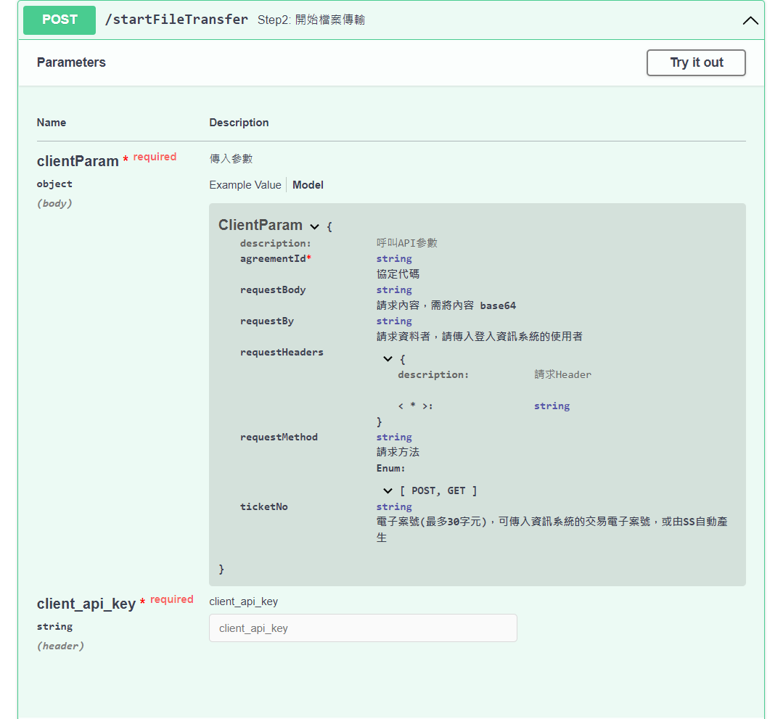
- 傳入參數規格
{
"agreementId": "string",
"requestBody": "string",
"requestBy": "string",
"requestHeaders": {
"additionalProp1": "string",
"additionalProp2": "string"
},
"requestMethod": "POST",
"ticketNo": "string"
}
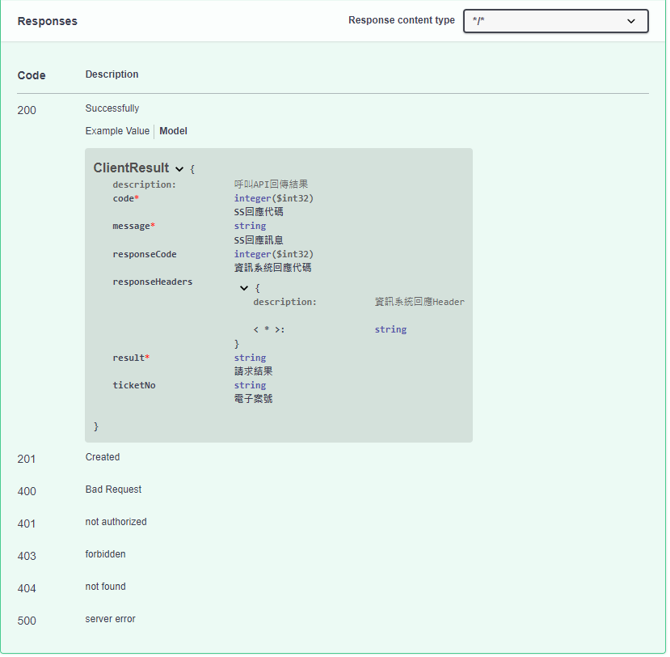
- 回傳結果規格
{
"code": 0,
"message": "string",
"responseCode": 0,
"responseHeaders": {
"additionalProp1": "string",
"additionalProp2": "string"
},
"result": "string",
"ticketNo": "string"
}

- fileTranferStatus檔案傳輸狀態
取得檔案傳輸狀態，若資料已經傳輸完成，則回傳SFTP帳號密碼，可透過SFTP下載檔案。
- 範例請求指令
curl -X POST "https://xxxxx.troad.gov.tw:8446/client/fileTransferStatus" -H "accept: */*" -H "client_api_key: xxx" -H "Content-Type: application/json" -d "{ \"agreementId\": \"0001\", \"ticketNo\": \"20221005-0000000005\"}" -k
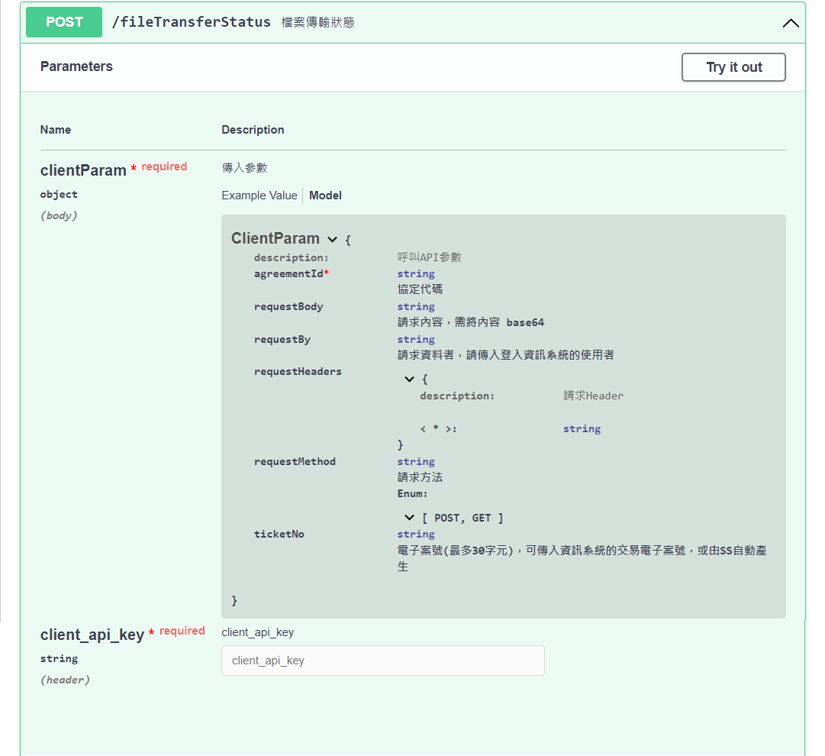
- 傳入參數規格
{
"agreementId": "string",
"requestBody": "string",
"requestBy": "string",
"requestHeaders": {
"additionalProp1": "string",
"additionalProp2": "string"
},
"requestMethod": "POST",
"ticketNo": "string"
}
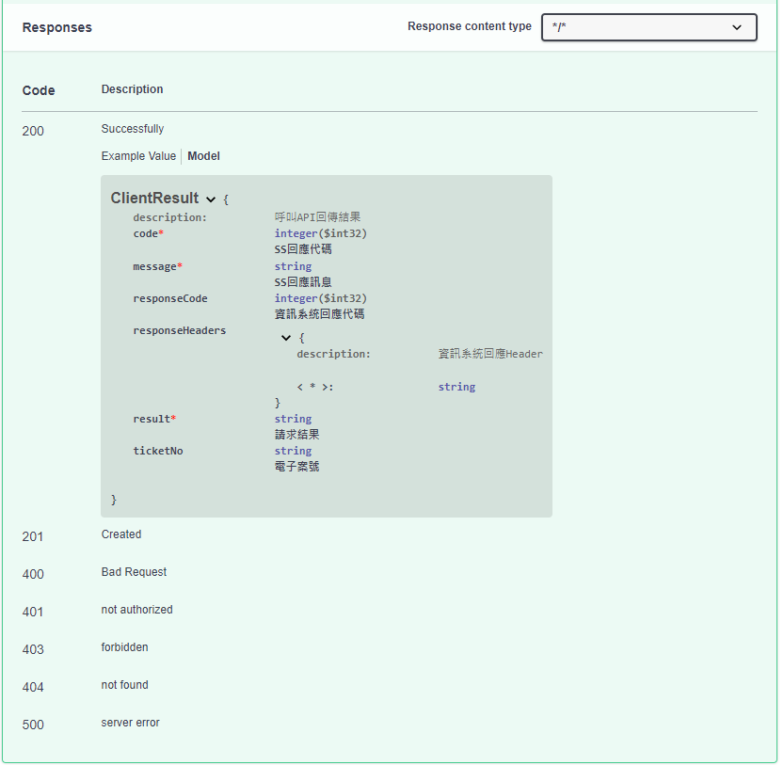
- 回傳結果規格
{
"code": 0,
"message": "string",
"responseCode": 0,
"responseHeaders": {
"additionalProp1": "string",
"additionalProp2": "string"
},
"result": "string",
"ticketNo": "string"
}

- 更新非同步API傳輸狀態API
- asyncApiCallback更新傳輸狀態
當提供端AP準備完成非同步資料後，呼叫此API並傳入收到請求時Header中的tr_callback內容，以更新此筆傳輸狀態，當請求端再次呼叫時，將準備完成的資料回傳。
- 範例請求指令
curl -X POST "https:// xxxxx.troad.gov.tw:8446/client/asyncApiCallback" -H "accept: */*" -H "Content-Type: text/plain" -d "tr_callback內容" -k
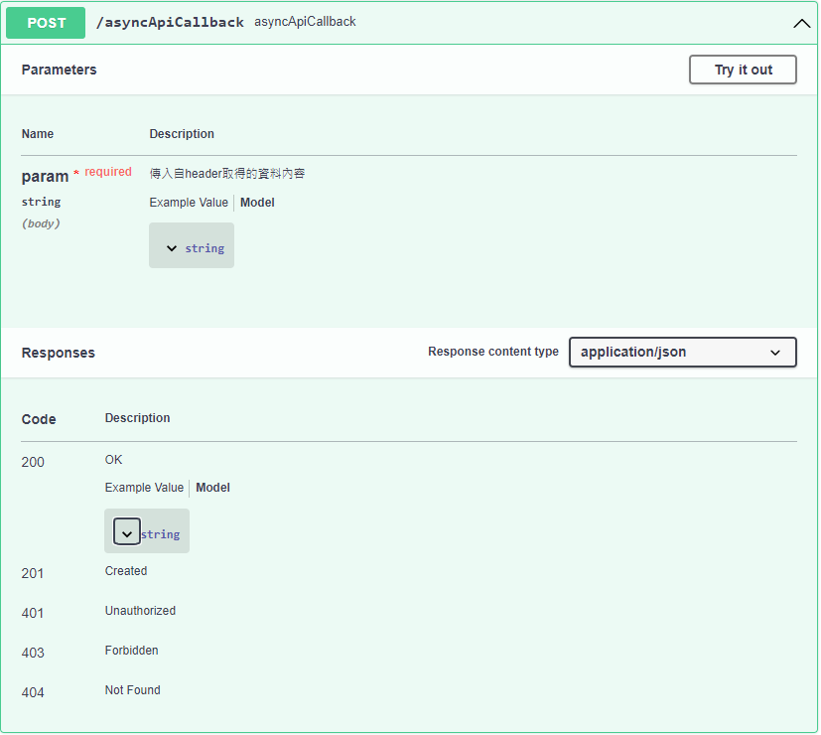

- 查詢傳輸紀錄API
- transactionApi查詢傳輸紀錄
- 範例請求指令
curl -X POST "https://xxxxx.troad.gov.tw:8446/client/transactionApi" -H "accept: */*" -H "client_api_key: xxxxxxx" -H "Content-Type: application/json" -d "{ \"agreementId\": \"A41000000G-009-0001-0001\", \"maxSizeOfPage\": 50, \"paginationPage\": 0, \"searchEndDate\": \"2021-01-01\", \"searchStartDate\": \"2021-01-01\", \"transactionStatus\": \"success\"}"
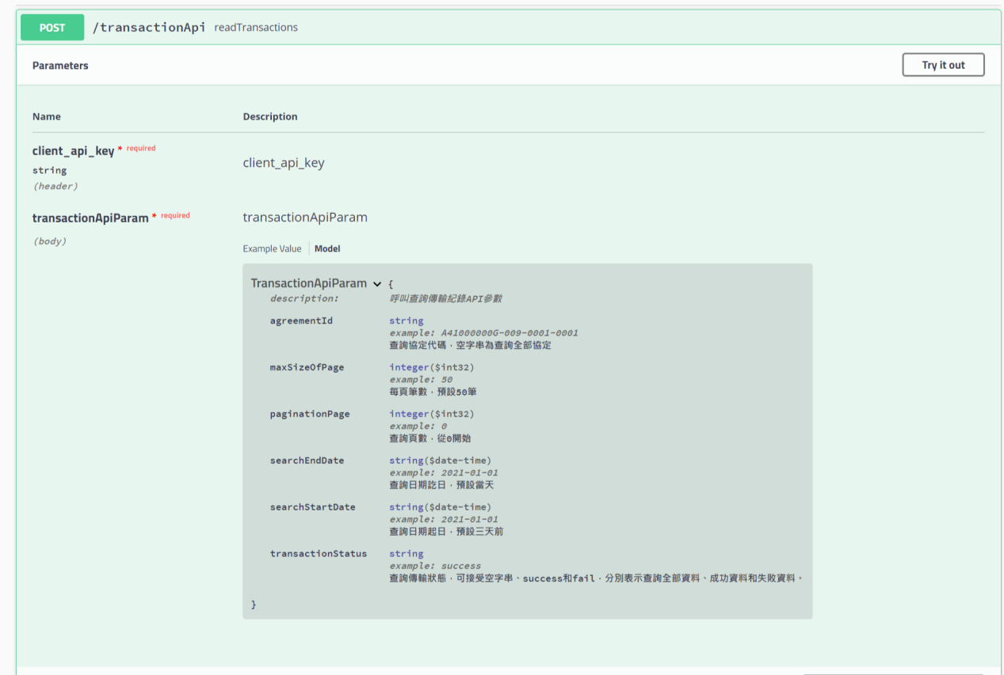
- 傳入參數規格
{
"agreementId": "A41000000G-009-0001-0001",
"maxSizeOfPage": 50,
"paginationPage": 0,
"searchEndDate": "2021-01-01",
"searchStartDate": "2021-01-01",
"transactionStatus": "success"
}
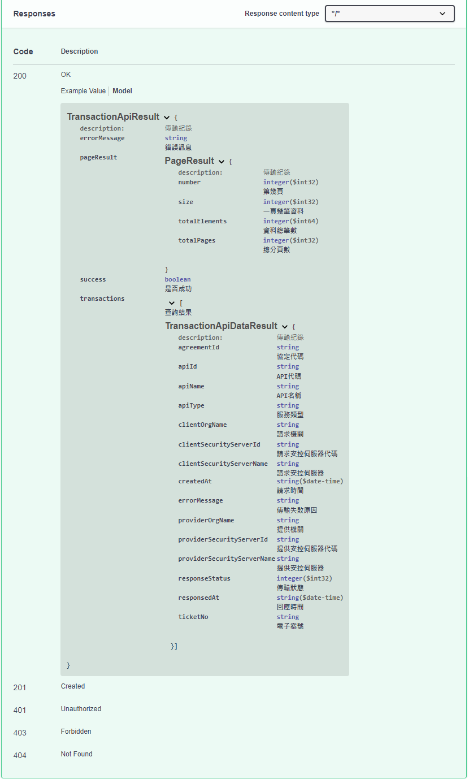
- 回傳結果規格
{
"errorMessage": "string",
"pageResult": {
"number": 0,
"size": 0,
"totalElements": 0,
"totalPages": 0
},
"success": true,
"transactions": [
{
"agreementId": "string",
"apiId": "string",
"apiName": "string",
"apiType": "string",
"clientOrgName": "string",
"clientSecurityServerId": "string",
"clientSecurityServerName": "string",
"createdAt": "2022-11-23T09:49:18.846Z",
"errorMessage": "string",
"providerOrgName": "string",
"providerSecurityServerId": "string",
"providerSecurityServerName": "string",
"responseStatus": 0,
"responsedAt": "2022-11-23T09:49:18.846Z",
"ticketNo": "string"
}
]
}

